# Lab: Ownership Chain

|  |
| --- |
| * This is an in-class lab, and worth 10 points. * This is due tonight (Mar 26). * Use the following naming convention: homework, underscore, last name, first initial, and extension (e.g., Lab_Ownchain_ImG.docx). |

* (**Task 1**) Show the outcome of this task in a screenshot. Also, explain briefly why you have received that result.

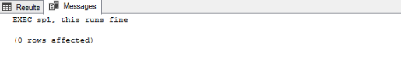

SP1 has no owner and we granted permission for SP1 to execute for TestUser01

* (**Task 2**) Show the outcome of this task in a screenshot. Also, explain briefly why you have received that result.

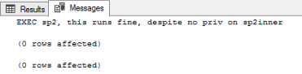

SP1 has no owner and we granted permission for SP2 to execute for TestUser01

* (**Task 3**) Show the outcome of this task in a screenshot. Also, explain briefly why you have received that result.

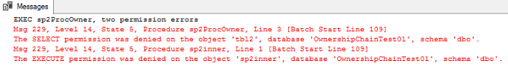

SP2ProcOwner is owned by ProcOwner01. TestUser01 does not have select permission no execute permission. Testuser01 has execute does not have execute permission for sp2inner.

* (**Task 4**) Show the outcome of this task in a screenshot. Also, explain briefly why you have received that result.

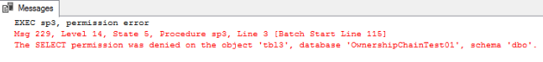

Table3Owner is owned by TableOwner01so TestUser01 has no select permission.

* (**Task 4**) Show the outcome of this task in a screenshot. Also, explain briefly why the result is different from the one from Task #4?

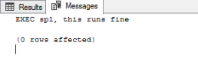

System admin can access anything and does not need permission for this specific object.